CREATIVE EDUCATIONAL SERVICES
END OF TERM II EXAMINATIONS, 2024
PRIMARY FOUR
INTEGRATED SCIENCE
DURATION: 2 ¼ HOURS.

NAME:_________________________STREAM______
DATE:________________________________
Final mark
INSTRUCTIONS:-
- Avoid unnecessary crossing of work.
- Write well.
- Read the instructions carefully and answer all questions.
- Wrong spellings will lead to loss of marks.
5. All work written in pencil except diagrams, will NOT be
marked.

Section A.( 40 marks)
1) Name the part of the human body used for smelling.
_____________________________________________________________________
The diagram below shows a split bean seed.
R

2) What will part R develop into after germination?
_____________________________________________________________________
3) How can a crop farmer keep the soil fertile?
_____________________________________________________________________
4) Write any one danger caused by strong wind in the environment.
_____________________________________________________________________

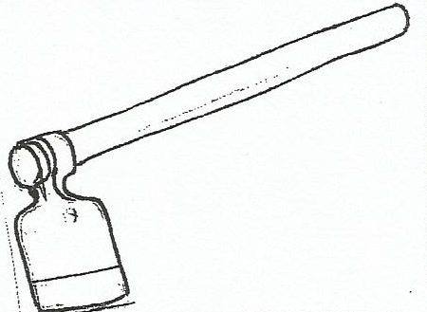
5) The diagram below shows a garden tool. State the use of garden tool below.

_____________________________________________________________________
6) Why is a housefly considered to be a vector?
_____________________________________________________________________
7) Which human body organ pumps blood to all parts of the body?
_____________________________________________________________________
8) How are insects like bees, butter flies and moths useful to crop farmers?
_____________________________________________________________________
9) In the space below, draw a diagram which shows that air occupies space.

10) Identify any one place in our homes, where germs are found.
_____________________________________________________________________
11) Name the immunisable disease which causes skin rash and red eyes to a person.
_____________________________________________________________________
The diagram below shows part of a plant.
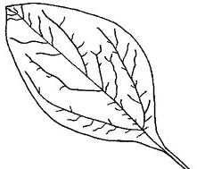

12) Give the use of the above part to plant.
__________________________________________________________________
13) Mention any one way water contamination can be controlled in our homes.
_____________________________________________________________________

14) Identify a food stuff which can be preserved by smoking.
_____________________________________________________________________
The diagram below, shows a method of planting crops.

15) Give any one advantage of the above method of planting crops to farmers.
_____________________________________________________________________
16) Which part of an onion plant is eaten as food?
_____________________________________________________________________
17) Identify any one people made change in the environment.
_____________________________________________________________________
18) Why do people plant short grass in their home compounds?
_____________________________________________________________________
19) Mention any one item in our homes, used to keep the compound clean.
_____________________________________________________________________
20) Which type of weather do crop farmers use to winnow their seeds?
_____________________________________________________________________
21) Draw and name any one item used in keeping toilets clean.

22) Name the main natural source of water in the environment.
_____________________________________________________________________
The diagram below, shows a plant process.
Droplets of water

Polythene paper

23) How is the process useful to our environment?
_____________________________________________________________________
24) In one sentence, briefly explain how a shadow is formed.
_____________________________________________________________________
25) Mention any one way people can keep healthy without using medicine.
_____________________________________________________________________
26) Identify the danger caused by wild birds to the environment.
_____________________________________________________________________
27) Why are cats grouped under livingthings?
_____________________________________________________________________
28) Identify any one factor which can cause failure for a seed to germinate.
_____________________________________________________________________
29) Why do people iron their clothes after washing them?
_____________________________________________________________________
30) Write any one resource that can be used for making footballs.
_____________________________________________________________________
31) How do we keep our teeth clean?
_____________________________________________________________________
32) Mention a communicable disease which can be spread from one person to
another through an insect bites.
_____________________________________________________________________

33) In which season do people harvest cereals?
_____________________________________________________________________
34) Why should drugs and poison be kept away from reach of children in a home?
_____________________________________________________________________
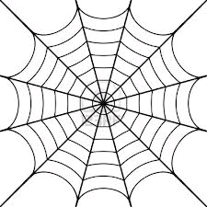
The diagram below shows a habitat for a spider.

35) Write the use of the above habitat to a spider.
_____________________________________________________________________
36) Give an example of a flowering plant which provides people with fruits.
_____________________________________________________________________
37) Identify the body organ which is protected by the skull.
_____________________________________________________________________
38) How do people prepare cassava tubers before eating it?
_____________________________________________________________________
39) Mention any one product made from animal skin and hides.
_____________________________________________________________________
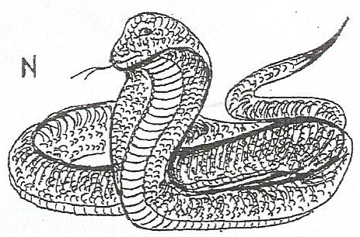
40) How does the animal below move from one place to another?

_____________________________________________________________________

SECTION B.(60 MARKS)
41) Match the words in A to their meaning in B correctly.
A B
soil Sinking of plant nutrients to deeper layers of the soil.
soil profile The vertical arrangement of soil layers.
soil erosion The top layer of the earth.
leaching Removal of top soil by its agents.
A B
a)_______________________ Sinking of plant nutrients to deeper layers of the soil
b)_______________________ The vertical arrangement of soil layers.
c) ______________________ The top layer of the earth.
d) ______________________ Removal of top soil by its agents.
42(a) Why is a bean seed grouped under dicotyledonous seeds?
_____________________________________________________________________
b) Mention the importance of the cotyledons in a bean seed.
_____________________________________________________________________
c) Give any two examples of seeds with the same number of cotyledons like a bean
seed.
i)____________________________________ii)_______________________________
43) The diagram below shows the different parts of an egg. Study it carefully
and answer the questions that follow:-
D
F

a) Name the part marked D and F.
i) D___________________________ii) F___________________________________
b) Identify the function of the part marked D to an egg ?
_____________________________________________________________________
c) By use of an arrow show the air space.

44(a) Give two reasons why people eat food?
i)____________________________________________________________________
ii)____________________________________________________________________
b) Mention the food value people get when they feed on the following food stuffs;
i) beans __________________________________________________________
ii)rice ___________________________________________________________
45(a) Write any two ways in which trees are useful to people.
i)____________________________________________________________________
ii)____________________________________________________________________
b) In the space below, draw root system of elephant grass.

(c)Give any one use of roots to plants.
_____________________________________________________________________
46 (a) Write any two uses of the sun to people.
i)____________________________________________________________________
ii)____________________________________________________________________ b) In which one way is the sun dangerous to people ?
_____________________________________________________________________
c) Why do green plants need sunlight?
_____________________________________________________________________
47. The diagram below shows a fish. Study it and answer the questions
which follow.
K
R
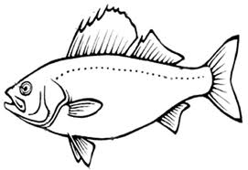
E

- Name the parts labelled E and R.
- E __________________________ (ii) R __________________________

- Give the use of part labelled K to fish.
___________________________________________________________________
- Which food value do we get from eating fish?
___________________________________________________________________
48a) What causes AIDS?
_____________________________________________________________________
b) Mention any one way we can control the spread of AIDS in our sub county.
_____________________________________________________________________
c) How do we care for AIDS patients?
i)____________________________________________________________________
ii)____________________________________________________________________
49) The diagrams below shows animals. Study them and answer
the questions which follow:-
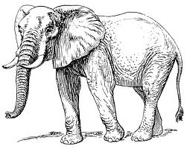
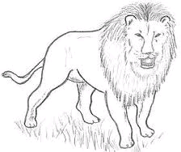

E
G

a) Identify the animals marked E and G.
i) E____________________________ii) G__________________________________
b) Which type of animals are shown above?
_____________________________________________________________________
c) Where do the above animals stay?
_____________________________________________________________________
50(a) Where do mosquitoes lay their eggs?
_____________________________________________________________________
b) How are anopheles mosquitoes dangerous to human beings?
_____________________________________________________________________

c) Give any two ways we can control the spread of mosquitoes in our community.
i)____________________________________________________________________
ii)____________________________________________________________________
51(a) What is a pest?
_____________________________________________________________________
b) Write any two examples of crop pests you know.
i)____________________________________________________________________
ii)____________________________________________________________________
c) Identify one method of controlling pests in a maize garden.
_____________________________________________________________________
52a) What causes dehydration?
_____________________________________________________________________
b) Mention any one sign of a dehydrated person.
_____________________________________________________________________c) Why should a dehydrated person be given ORS?
_____________________________________________________________________
53(a) Briefly explain soil erosion.
_____________________________________________________________________
b) Give one example of agents of soil erosion.
_____________________________________________________________________
c) Mention any two ways of controlling soil erosion in gardens.
(i) ___________________________________________________________________
(ii)___________________________________________________________________
54. The equipment below is used by first aider.

(a) Mention any one place where we find this equipment.
_____________________________________________________________________
b) Name any one materials found in the equipment above.
_____________________________________________________________________

c) State any two reasons why people give first aid to casualties.
i)____________________________________________________________________
ii)____________________________________________________________________
55(a) Give any two processes through which rainfall is formed.
i)____________________________________________________________________
ii)____________________________________________________________________
b) Name the cloud which acts as a sign of rainfall.
_____________________________________________________________________
(c) Draw and name any one material used for collecting rain water.

